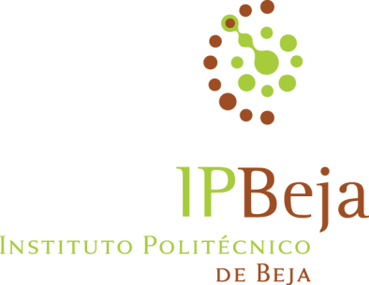

Sofia Ramôa
Chave pública FCT: J5282774GOS9
ORCID ID: orcid.org/0000-0001-7756-3037

Areas of Scientific activity

Water-use efficiency under water deficit condition, in perennial crops. Natural resources conservation (soil, water and biodiversity).

applying appropriate irrigation strategies under Mediterranean climate conditions

Bio
Sofia Ramôa is a professor in Polytechnic Institute of Beja / Agrarian School. She teaches subjects like Soils, Climate and Irrigation Techniques addressed to courses in the area of Agronomy. Currently she participates in 2 research projects concerning to irrigation strategies in pomegranate orchards (0049_INNOACE_4_E project / task 6) and evaluation of the water footprint in vineyards (SAICT-POL/23360/2006 project), both under Mediterranean climate conditions. Distinction under the SEMh - Phytoma 2015 Prize, awarded by SEMh - Sociedade Española de Malherbología for having been in the 4 best oral presentations presented at the XV Congress of the Spanish Society of Malherbología, October 19-23, 2015, Seville.

Education
- 2014: Ph.D. in Biology and Plant Production, Extremadura University – Spain. Thesis ‘Characterization and dynamics of flora biodiversity in crops of Baixo Alentejo (Portugal). Analysis of the impact of environmental factors’.
- 1997: M. Sc. in Plant Production. Instituto Superior de Agronomia, Lisbon University. Thesis ’Effect of sprinkler irrigation by center pivot on potential soil productive in corn yield’.
- 1990: Degree in Agronomic Engineering, Instituto Superior de Agronomia, Lisbon University.

